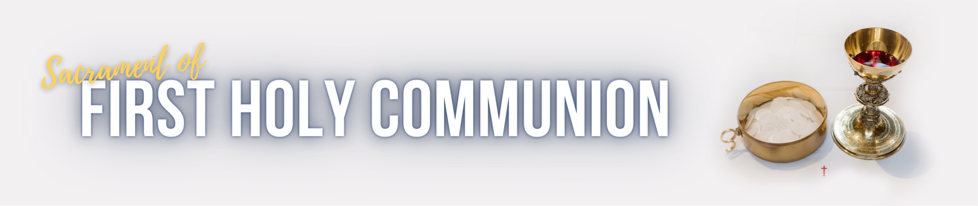

Dear Parents and Caregivers
Thank you for seeking to prepare your child/children for the Sacrament of First Holy Communion and Reconciliation. We really look forward to journeying with you as a family. Faith is a whole family experience, as parents are the first teachers of the faith to their children. We are here to support you as you nurture your child/children’s love and knowledge of God.
This letter will outline all you need to know about the Sacramental Journey:

What are the requirements?
- Your child will need to have received the Sacrament of Confirmation and be in year 4 or above.
- A completed Enrolment form with signatures from both parents. Please see the link on our webpage and submit electronically.
- Enrolment fee of $50. This can be paid in person at the information night or parish office, Eftpos is available; or bank transfer as below.
Account Name | Account Number | BSB | Reference
OLSC General | 100022973 | 064 786 | Child’s initial and surname (EG. J Smith)

- The whole family is invited to attend as it is fun and family focused program. At least one parent needs to come along with the candidate.
- Choose your date and time of First Holy Communion. This will be in the enrolment form.
*If your child received Confirmation at another Parish, we will need a copy of the certificate of Confirmation. Please scan it and email to sacraments.springfield@bne.catholic.net.au

Where will the Sacramental Journey be held?
The Augustine Centre at St Augustine’s College. St Augustine’s Drive, Augustine Heights.

What do we need to do in preparation for the special day?
- Dress attire is a white dress and veil for the girls, and a white shirt and smart pants for the boys. Veils are available for sale in the Parish store.
- Please arrive 30 minutes prior to the start of your chosen Mass time.
- A parish photographer will be present to take shots of this special moment. Due to safeguarding requirements, personal footage/photos is not allowed. Photos can be purchased for $5 after the ceremony. Please note that our 9am Mass is a livestreamed event. A media consent form will be given to you to sign at our parent information night.
What is the schedule?
The Sacramental Journey runs for 6 weeks from 6:30pm to 7:30pm. You can attend either a Wednesday night or a Thursday night. Please decide which night suits your family roster.
Schedule | Wednesday | Thursday
Parent Information Session *compulsory | 12 October | 13 October
Week 1 | 19 October | 20 October
Week 2 | 26 October | 27 October
Week 3 | 2 November | 3 November
Week 4 | 9 November | 10 November
Week 5 | 16 November | 17 November
*Parent information Session will be a time to ask any questions, hand in your paperwork and make payment.

What are the special dates you need to lock in?
Parent Information Session | Parents need to attend this information session in order to take the next steps of preparation. It is a compulsory step to attend the Sacramental Journey. | Please choose from one of the following nights:  Date: 12 October at 6:30pm – 7:30pm  Or  Date: 13 October at 6:30pm – 7:30pm  At St Augustine’s College in the Augustine Centre.
Rite of Enrolment and Presentation to the community. | Your child will receive this beautiful Rite in Mass at OLSC Parish before the Sacramental Journey begins.  There will be prayer card distribution too. | Date: 15/16 October 2022  Please attend one of the Weekend Masses.  Saturday: 5pm  Sunday: 7:30am, 9am or 11am
Practice Session | The candidates will learn the practical steps that will occur during the Mass. | Date: 12/13 November 2022  Practice will occur after each Mass at OLSC Parish. Please choose a time that suits your family.  Saturday: 5pm  Sunday: 7:30am, 9am or 11am
First Holy Communion, Christ the King  Weekend. | This is the Mass when your child will receive the Sacrament of First Holy Communion. | Date: 19/20 November 2022  Please indicate in the Enrolment Form which Mass you will be attending.  Saturday: 5pm  Sunday: 7:30am, 9am or 11am

We are excited to journey with you and your families. Please don’t hesitate to contact us.
Parish office: 3324 3900
Email: sacraments.springfield@bne.catholic.net.au
In faith,
OLSC Sacramental Team.

