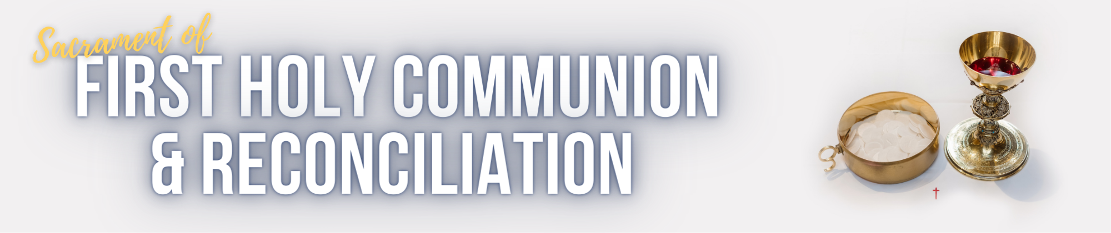

11 August 2023
Dear Parents and Caregivers
Thank you for seeking to prepare your child/children for the Sacrament of First Holy Communion and Reconciliation. We really look forward to journeying with you as a family. Faith is a whole family experience as parents are the first teachers of the faith to their children. We are here to support you as you nurture your child/children’s love and knowledge of God.
This letter will outline all you need to know about the Sacramental Journey:

What are the requirements?
- Your child will need to have received the Sacrament of Confirmation and be in year 4 or above.
- A completed enrolment form with signatures from both parents. Please see the link on our webpage and submit electronically. If your child received Confirmation at another parish, we will need a copy of the certificate of Confirmation. Please scan it and email to sacraments.springfield@bne.catholic.net.au
- Enrolment fee of $50. This can be paid by bank transfer, as below, or in person at the information night or parish office (Eftpos if available).

Account Name | Account Number | BSB | Reference
OLSC General | 100022973 | 064 786 | Child’s initial and surname (EG. J Smith)

- The whole family is invited to attend as it is fun and family focused program. At least one parent needs to come along with the candidate.
- Choose your date and time of First Holy Communion. This will be in the enrolment form.

What do we need to do in preparation for the special day?
- Dress attire is a white dress and veil for the girls, and a white shirt and smart pants for the boys. Veils are available for sale in the parish piety store.
- Please arrive 30 minutes prior to the start of your chosen Mass time.
- To avoid distractions during Mass, we discourage parents and guests from taking photos. A parish photographer will be present to capture this special moment. You may take photos after Mass. Photos taken by the official photographer will be available for purchase at $5/photo.
- There will be a group photo with Fr. Baiyi and the sacramental team and distribution of the certificates after Mass. However, please be mindful that after the 9 am Mass, we need to prepare for the 11 am Mass. Therefore, while we encourage you to take as many photos as you want, please continue at the back or outside the church.

What are the special dates you need to lock in?
Parent Information Session | Parents need to attend this information session in order to take the next steps of preparation. It is a compulsory step to attend the Sacramental Journey.  It will be held at Our Lady of the Southern Cross Church (OLSC) 58 Opperman Drive, Springfield Lakes. | Please choose from one of the following nights:  Date: Monday, 09 October  6:30pm – 7:30pm  Or  Date: Tuesday 10 October  6:30pm – 7:30pm
Rite of Enrolment and Presentation to the Community. | Your child will receive this beautiful Rite in Mass at OLSC Parish before the Sacramental Journey begins.  There will be prayer card distribution too. It is a compulsory step to attend the Sacramental Journey. | Date: 14/15 October 2023  Please attend one of the Weekend Masses.  Saturday: 5pm  Sunday: 7:30am, 9am or 11am
Week 1  Week 2  Week 3  Week 4  Week 5 | Preparation Journey  6:30 to 7:30pm  Monday or Tuesday  All sessions are compulsory and will be held at OLSC | Dates:  16 or 17 Oct  23 or 24 October  30 or 31 October  06 or 07 November  13 or 14 November
Practice Session | Please attend the Mass. The candidates will learn the practical steps that will occur during the Mass.  Practice will be after each Mass at OLSC Parish. | Dates: 18/19 November 2023  Please choose a time that suits your family.  Saturday: 5pm  Sunday: 7:30am, 9am or 11am
First Holy Communion, Christ the King  Weekend. | This is the Mass when your child will receive the Sacrament of First Holy Communion. | Date: 25/26 November 2023  Please indicate in the Enrolment Form which Mass you will be attending.  Saturday: 5pm  Sunday: 7:30am, 9am or 11am

We are excited to journey with you and your families. For any queries, please do not hesitate to contact us.
Parish office: 3324 3900
Email: sacraments.springfield@bne.catholic.net.au
In faith,
OLSC Sacramental Team.

