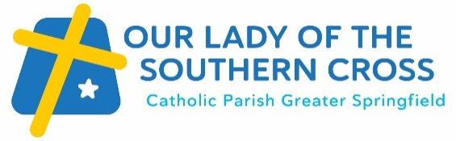 | Preparing for Baptism

Welcome! We are excited you have made this decision to prepare for Baptism and welcome you and your family to our parish. We understand that Baptism is an important time for you, and we want to be part of that journey.

Faith is one of the most beautiful gifts we can give our children, yet many parents don’t feel equipped to take on the responsibility of helping their children come to know Jesus. Our programme is designed to help parents reconnect with their faith, connect with other families, and connect with our community so they are supported as they embark on this journey. It is an opportunity to explore aspects of our Catholic faith through a combination of facilitated discussion and coming to weekend mass over a 6-week period as follows:

Week 1 | Session 1: “The Power of Prayer” (Sunday 10:30am – 11:45am)
Week 2 | Attendance at weekend mass (5pm Sat, 9am or 11:00am Sun)
Week 3 | Session 2: “Who is Jesus” (Sunday 10:30am – 11:45am)
Week 4 | Attendance at weekend mass (5pm Sat, 9am or 11:00am Sun)
Week 5 | Session 3: “The sacrament of baptism” (Sunday 10:30am – 11:45am)
Week 6 | Attendance at weekend mass (5pm Sat, 9am or 11:00am Sun)

We run 4 baptism preparation sessions per year. Our 2024 dates are:

Term 1: Sunday 11th February – 17th March
Term 2: Sunday 5th May – 9th June
Term 3: Sunday 14th July – 18th August
Term 4: Sunday 13th October – 17th November

Baptism brings your child into a relationship with Jesus as they become a member of the family of God and become part of our community. This is why we celebrate Sacrament of Baptism during our weekend masses (Saturday vigil, 5pm, or Sunday mornings, 9am or 11:00am) rather than private occasions.

Baptism for children 8 years to 16 years
To support children between 8-16 years as they take these first steps into the Catholic faith, we have lessons to help them understand what Baptism means and what to expect on Baptism Day. These interactive lessons are in addition to and separate from the parental preparation outlined above.
To join us for our next Baptism preparation, please complete the registration form using this link: OLSC Baptism - Registration of Interest | UCare (ucareapp.com) and a member of our baptism team will be in contact with you.

If you have previously completed Baptism preparation with our parish, please connect with our parish team by phone (07) 3324 3900 or email springfield@bne.catholic.net.au

“Go therefore and make disciples of all nations, baptising them in the Name of the Father, and of the Son and of the Holy Spirit, teaching them to observe everything I that I have commanded you.”  – Matthew 28:19-20 | 